**DEMO SCRIPT**

1. Introduce app(follow the main documentation, give a backstory of our PowerSaver App, its aim and what it does etc), feature, show user journey, some use cases/diagrams
2. Code demo (3 actor: A-normal user, B-admin, C-normal user)

* A register for a normal user:
  + register for a valid and easy-to-remember account
  + Login with username but password empty- the app should return an error
  + Log in with the actual account
  + Show that we can change the name, and email address(come to the account detail page for updating)
  + Add in 3 devices:
    - (using custom device) ceiling fan -50 W -10h(explain only numeric input is allowed)
    - (using custom device) ceiling fan - 50W- 25h(explain this should fail)
    - (using custom device) television - 100W- 10h30
    - (using custom device) television - 100W- 12h
  + Show the data visualization, bill
  + Delete the television:
    - show that the bill, and data visualization also update accordingly
  + Log out and show that logout works
* B register for admin:
  + leave the field empty and register - the app should return an error
  + fill in an account that is easy to remember and register
  + log in and add in 2 devices:
    - Air Conditioner: 3000W
    - Television: 100W
    - Washing machine: 500W
    - Fridge: 400W
  + Log out
* C register for a normal user:
  + register for an account with the same username as A - the app should return an error
  + register for another valid and easy-to-remember account
  + Log in with the actual account
  + Change password so that it log C out and then log in again
  + Add in 3 devices:
    - (using Air Conditioner) air conditioner- 10h(explain that is because admin has set the default value for the model)
    - (using Washing Machine) washing machine- 0h30
    - (using Fridge)fridge- 24h
    - (using Television)television -8h
  + Increase airconditioner to 24h and change from 3000W to 3400W:
    - show the dashboard (exceeding the national average) and the notification
    - show bill
    - export report and send to email

1. Potential for future use
2. Explain good SE practice

## Code Organization and Structure

* divided the code into package with MVC model and take picture

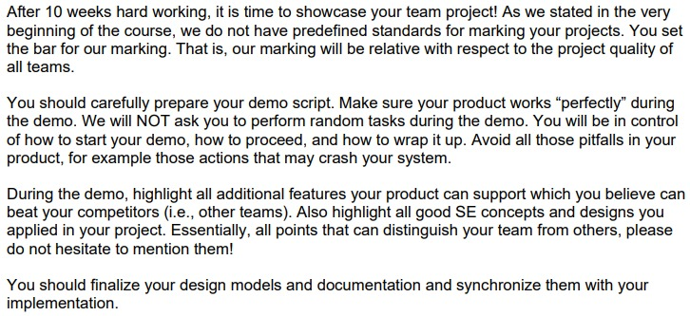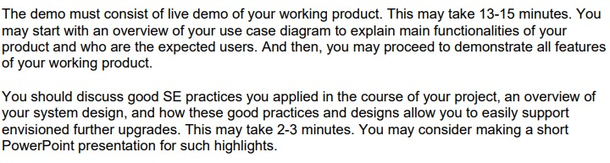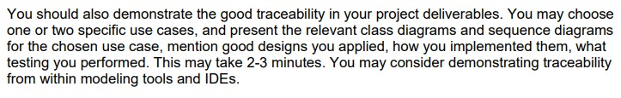

# User Inputs for demo:

**1. User demonstrates login**

Login screen:

username: john123

password: password

<display invalid username/password> - user account not registered

**2. User attempts to register without filling out username**

username:

password: password

full name: John Smith

email: <personal email>

<system prompts user to fill in all the fields>

**3. User registers a new account**

username: john123

password: password

full name: John Smith

email: <personal email>

<account successfully created and redirected to login screen>

**4. User enter an incorrect password**

username: john123

password: 123

<invalid password>

**5. User enters correct credentials and login**

username: john123

password: password

<user logins successfully & redirected to dashboard>

<dashboard displays 0 devices and usage>

**6. User expand dashboard tabs** - show that there's nothing in the dashboard

**7. User clicks on ‘Manage Devices’**

<display empty device manager list>

**8. User clicks on ‘+’ button**

<redirected

**9. User add computer with hours and mins empty**

Select ‘computer’

Device Name: MyPC

Usage: 50 (default)

Hours: <empty>

Mins: <empty>

<system prompts user to input all fields>

**10. User enter all values**

~

Hours: 24

Mins: 30

<system prompts time cannot be >24hrs>

**11. User changes hours from 24 to 12**

~

Hours: 12

Mins: 30

<device added successfully and reflected on device list>

**12. User clicks on menu to go to dashboard**

**13. User shows that dashboard are updated (click on expand buttons)**

**14. User clicks on ‘Manage Devices’ in Power Fragment**

<redirected to manage device list>

**15. User clicks ‘Remove’ on MyPC device**

<device list updated to empty>

**16. User swipe back to dashboard**

<show that dashboard is empty>

**17. User clicks on Manage Devices again**

**18. Add Device: TV**

Device Name: MyTV

Consumption: +5 of default

Hours: 12

Mins: 41

<updated device manager list>

**19. Add 2nd device: Custom Device**

<default values are 0>

Device Name: Mini Fridge

Consumption: 80

Hours: 24

Mins: 00

<2 devices reflected and show accuracy of information>

**20. Add 3rd device: Computer**

Device Name: MyPC

Consumption: 50

Hours: 15

Mins: 45

<3 devices reflected>

**21. User edits MyPC**

Device Name: MyPC

Consumption: 69

Hours:

Mins:

<Save device> → error: system prompts user to enter hours and mins

**22. User fixes inputs**

Device Name: MyPC

Consumption: 69

Hours: 9

Mins: 20

<Save and 3 devices are updated on the device manager list>

**23. User returns to dashboard**

<show that the information on dashboard is updated>

**24. User attempts to go over national average**

**25. User add 4th device**

Device Name: Server

Consumption: 3000

Hours: 24

Mins: 00

<device list updated with 4 devices>

**26. User returns to dashboard**

<ALERT notification displayed>

<dashboard updated with the 4 devices>

**27. User logs out**

<redirected to login>

**28. Register new user**

username: john123

password: test

name: John Adams

email: <personal email>

<ERROR: username exists>

**29. Register new user again**

username: john456

password: test

name: John Adams

email: <personal email>

<successful account creation>

**30. Login with john456**

<redirected to dashboard>

**31. Navigate to Account Details**

username: john123

password: test

name: John Adams

email: <personal email>

<ERROR: username exists>

**32. Change name and username**

username: john789

password: test

name: John Williams

email: <personal email>

<save and logout>

**33. Login as john456**

username: john456

password: test

name: John Williams

email: <personal email>

<login failed>

**34. Login as john789**

username: john789

password: test

name: John Williams

email: <personal email>

<login successful>

**35. Add Device: Computer**

Device Name: MyPC

Consumption: 69

Hours: 9

Mins: 20

<device list updated>

<return to dashboard>

**36. User demonstrates forget password**

**37. User demonstrates Export PDF**

**38. User shows device downloads folder**

**39. User shows their personal email with the exported pdf <tentative>**

# Administrator inputs (<20 steps):

* Administrator demonstrates forget password procedure
* The administrator navigates to the main admin page
* Administrator demonstrates add devices (microwave, 45 watts)
* Administrator adds aircon (100 watts)
* Edit computer from default to 80 watts
* Save
* Logout
* login as john789, password: test
* Add device → show that new devices reflected and power usage for the computer is 80.